Contents

Powering the Arduino Uno 1

Connecting the RockBLOCK 2

Upper Headers 2

Lower Headers 2

Connecting the Sensors 4

References 5

## Powering the Arduino Uno

Connecting a battery to the Uno is straight forward, connect the positive terminal to the VIN Pin and the negative to one of the GND pins. (see Figure 1)

It is manufacturer recommended to power the Uno with a voltage source between 7 and 12 volts, depending on the current draw requirements of the Uno and connected components.

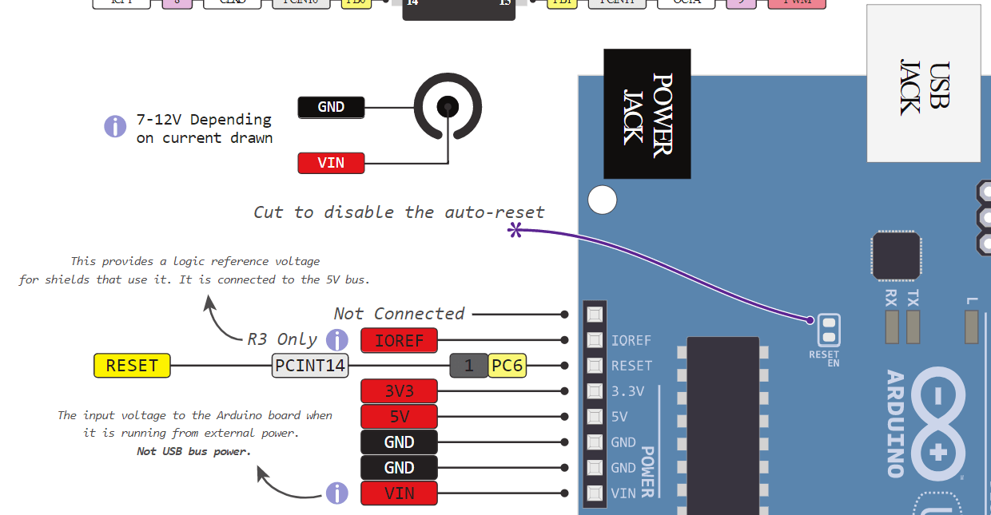

Figure 1. Arduino Uno Powering Device Pinout

## Connecting the RockBLOCK

The RockBLOCK has two sets of headers (as can be seen in Figure 2). The upper set, consisting of 6 pins, is used for powering the RockBLOCK and communicating via UART with the host, which in this case is the Arduino Uno. The second set, consisting of 8 pins, is used for some of the RockBLOCK’s non-vital functions. We, for the most part, can ignore most of these pins.

For connecting the RockBLOCK, we will use the Arduino Uno’s digital pin headers. (see Figure 3) Since we are using the “Naked” version of the RockBLOCK (non-waterproof), the host will need to supply a minimum of 100mA @ 5V via a standard 0.1” pitch direct header connector, or optional FTDI USB adaptor.

## Upper Headers

The Uno pins 0 and 1, RXD and TXD respectively, will be connected to the RockBLOCK pins 2 and 3, also RXD and TXD respectively. **These pins need to be disconnected when compiling code (If using the Arduino Uno). See the first point under “Code Basics” in the “HAST Arduino Code Documentation” document located the project folder.**

The RockBLOCK pins 1 and 5, RTS (request to send) and CTS (clear to send), will be connected to pins 3 and 4 of the Uno. These are handshaking pins used to ensure that the RockBLOCK is ready to accept data over the TXD line.

Finally, to power the RockBLOCK, pins 4 and 6, Vcc and GND respectively are used. Whether we power the RockBLOCK through the Uno or via its own battery is yet to be determined.

## Lower Headers

Pin 11 of the RockBLOCK, NetAv, can be used for the Uno to poll for the network status via AT commands. This determines if the RockBLOCK has satellite connection, and can therefore broadcast a data packet. We will use this to ensure that if the data cannot be sent, it will be stored until a future date when it can be sent.

Pin 12 is used to power the RockBLOCK on and off, which will be used to turn the RockBLOCK off when not in use, maximizing power efficiency.

To power these pins, either pin 8 or 13, 5v In and LiIon respectively, and GND will be connected to a power supply. LiIon pin is used only when powering directly with a lithium ion battery.

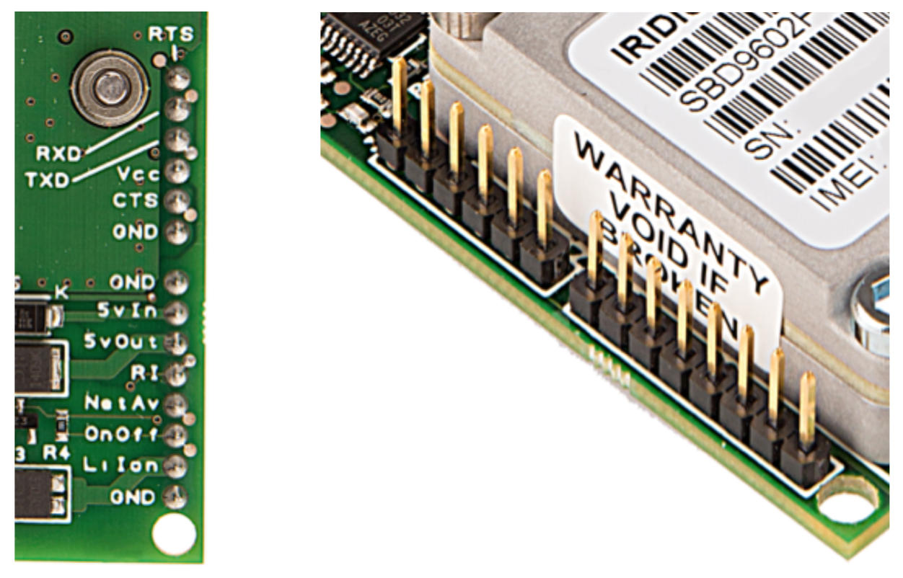

Figure 2. RockBLOCK Headers

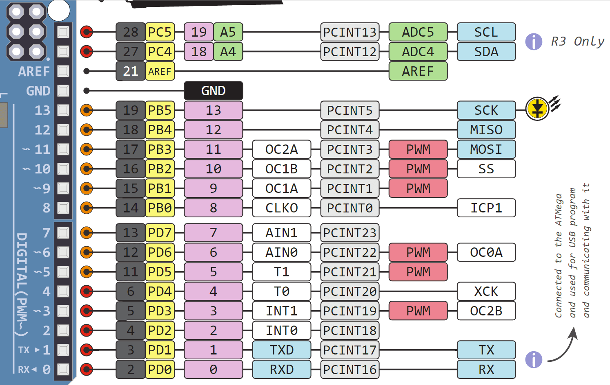

Figure 3. Arduino Uno Digital Pinout

## Connecting the Sensors

The SHT-10 sensors have 4 leads; the use of each can be seen in Table 1.

Since we are using only four sensors for our prototype, they will all share a pin for clock signal and data output from the digital pin headers in Figure 3.

Pin 14 is a serial clock (SCK) pin that will connect to the yellow SCK leads of all the sensors. (see Figure 3)

Pin 11, MOSI (master out slave in) SPI communication, will connect to the blue DATA leads of all the sensors. (see Figure 3)

The sensors will be powered on one at a time, which allows them to all share the same data output pin on the Uno. This will be done with pins A0, A1, A2, A3 as can be seen in Figure 4. These are labeled as Analog In, as they utilize the Uno’s ADC. They can, however, be used as digital in/out pins, and the ADC can be turned off to save power. They will all share a GND pin, seen in Figure 1.

Table 1. SHT-10 Sensor Lead Specifications

|  |  |  |  |
| --- | --- | --- | --- |
| Identification | Lead | Name | Comment |
| S | Yellow | SCK | Clock signal |
| + | Red | VDD | Power |
| - | Black or green | GND | Ground electrode |
| D | Blue | DATA | Data output |

Table 2. SHT-10 Sensor Technical Parameters

|  |  |
| --- | --- |
| **Parameters** | **Value** |
| Power Supply Voltage | 3 – 5.5V |
| Temperature Range | -40 to +123.8°C |
| Temperature Measurement Accuracy | +/- 0.3 - 0.5°C @ 25°C |
| Moisture Range | 0 – 100%RH |
| Humidity Measurement Precision | +/-1.8 - 4.5%RH |
| Power Usage | 80µW (12 measurement, 1time/s) |

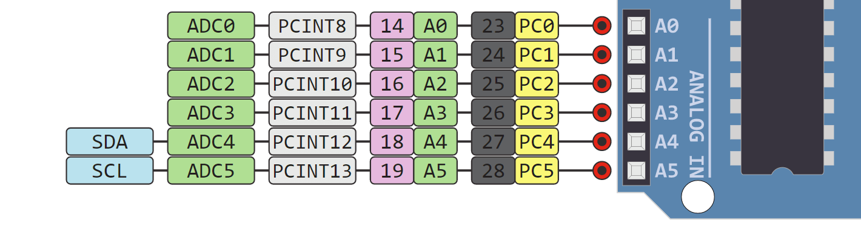

Figure 4. Arduino Uno Analog Pinout

## References

For the Arduino Uno Pinout images:

<https://www.circuito.io/blog/arduino-uno-pinout/>

For the RockBLOCK Pinout

file:///F:/Fall%202019/HAST%20Project/RockBlock/RockBLOCKDeveloperGuideMk2.pdf

For the SHT-10 Sensor info:

<https://cdn-shop.adafruit.com/datasheets/SLHT5.pdf>